St. Gerard Majella School

Learning and Support Policy

Preamble

St Gerard Majella School seeks to build and sustain a Catholic Christian community for all. We acknowledge the right of every child with special educational needs to an education that is as complete and appropriate as possible. We also acknowledge the need to support parents in attaining an appropriate education for their child.

Policy

St Gerard Majella School will strive to provide an inclusive curriculum that meets the needs of students with diagnosed disabilities and learning difficulties.

Values

Dignity, Justice, Respect, Inclusivity, Fairness and Compassion.

Principles

St Gerard Majella School has a process in place to identify and respond to the needs of students with specific needs which impact on their ability to access the curriculum.

This process:
- Ensures the early identification of learning difficulties and learning disabilities and other diagnosed disabilities which impact on learning.
- Responds to students’ identified learning needs through effective learning and teaching practices based on research.
- Uses inclusive curriculum practices that incorporate and capitalise on the diversity of knowledge, social and cultural experiences, beliefs and values of students.
- Provides a range of curriculum and flexible program options designed to respond to the individual learning needs of these students.
- Provides regular Case Conferences with specialised personnel and parents to consider individual students’ needs and plan for their future learning.
- Ensures that the placement of students into classes is done in consultation with the Principal, classroom teacher and the Learning Support teacher/s.
- Ensures that SGM follows the Supported Enrolment Process adopted by CES Cairns.
- Consideration will be given to the availability of physical, human and financial resources.

Definitions:

Learning difficulties and learning disabilities refer to barriers which limit some students’ access to, participation in and outcomes from the curriculum.

Students with learning difficulties are those whose access to the curriculum is limited because of short-term or persistent problems in one or more of the areas of literacy, numeracy and learning how to learn.

Students with learning disabilities are one small group of students with learning difficulties who because of the neurological or environmental basis of their difficulties, have persistent long-term problems and high support needs in one or more of the areas of literacy, numeracy and learning how to learn. These students do not have generalised intellectual impairments but rather demonstrate idiosyncratic learning styles, which are determined by the nature of their specific disorders and inhibit their learning at school.

Evaluation

This policy will be reviewed as part of the school’s renewal cycle.

This policy was last ratified by School Board on 27 April 2016

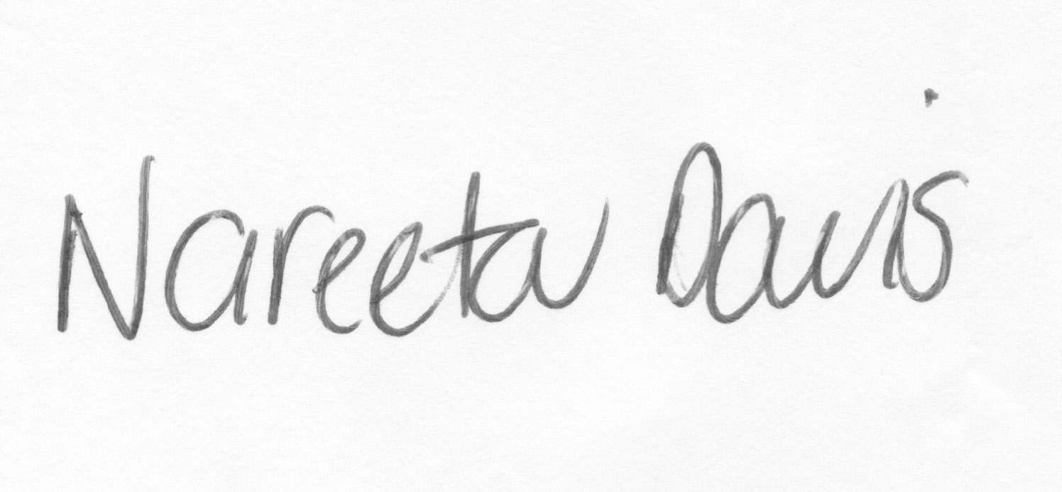
Chair Signature

