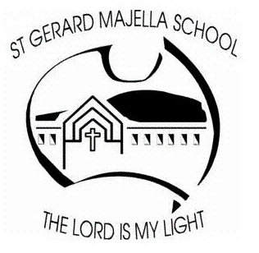 St. Gerard Majella School
School Behaviour Management
Policy

PREAMBLE

At St Gerard Majella School we emphasise the importance of the development of the whole person. This will be achieved by the implementation of ‘The SGM Way… A School Wide Positive Relationships Framework’ which provides an environment that promotes learning, respect, dignity and the safety of all.

POLICY

St Gerard Majella School community will consistently implement a clearly stated school wide positive relationships framework that encourages students to make appropriate choices and accept responsibility for their own behaviour. All members of our school community have rights, which need to be respected, and responsibilities to themselves and others. Bullying and anti-social behaviour in all its forms has no place at St Gerard Majella School.

VALUES
Faith, Justice, Inclusion, Compassion, Respect, Forgiveness, Acceptance, Empathy, Responsibility, Tolerance, Communication, Honesty and Fairness.

PRINCIPLES

- St Gerard Majella School will be proactive in behaviour management.

- School values will be simple, clear, well publicised and consistently enforced.

- Class expectations will be clear, concise and known to students and parents/guardians.

- Staff and senior students will be aware that their behaviour is seen as an example to the rest of the student body thereby assisting them in making positive behaviour choices.

- Consequences for both positive and negative behaviours will be logical and consistent.

- All involved in the process should work in collaboration by recognising the partnership between staff, parents/guardians and students that is necessary for successful behaviour change and positive relationships.

RELATED DOCUMENTS

- The SGM Way… A School Wide Positive Relationships Framework.

EVALUATION

This policy is to be reviewed as part of the School’s renewal cycle.

This policy was last ratified by School Board on 27 April 2016

Chair Signature

